

|  |
| --- |
| **MATHEMATICS DEPARTMENT**  **Year 11 Specialist – 2016**  **Test Number 6: Resource Free**  **Trigonometric Identities and Complex Numbers** |

**Name: _______________________________________ Teacher: DDA**

**Marks: 52**

**Time Allowed: 45 minutes**

**Weight: 7%  
Instructions:** Show your working where appropriate remembering you must show working for questions worth more than 2 marks. ________________________________________________________________________

Part A 9 multiple-choice questions

1 sec (45°) =

A 

B 

C 

D 

E 

[1 mark]

2 cos  =

A −2

B 

C 

D 

E  [1 mark]

3 sec =

A  −sec 

B −cos 

C  cos 

D  sec 

E  sec 

[1 mark]

4 cos (270° − α) =

A   sin (α)

B −sin (α)

C   cos (α)

D −cos (α)

E   cos (270°)

[1 mark]

5 The graph shown below could have the equation:

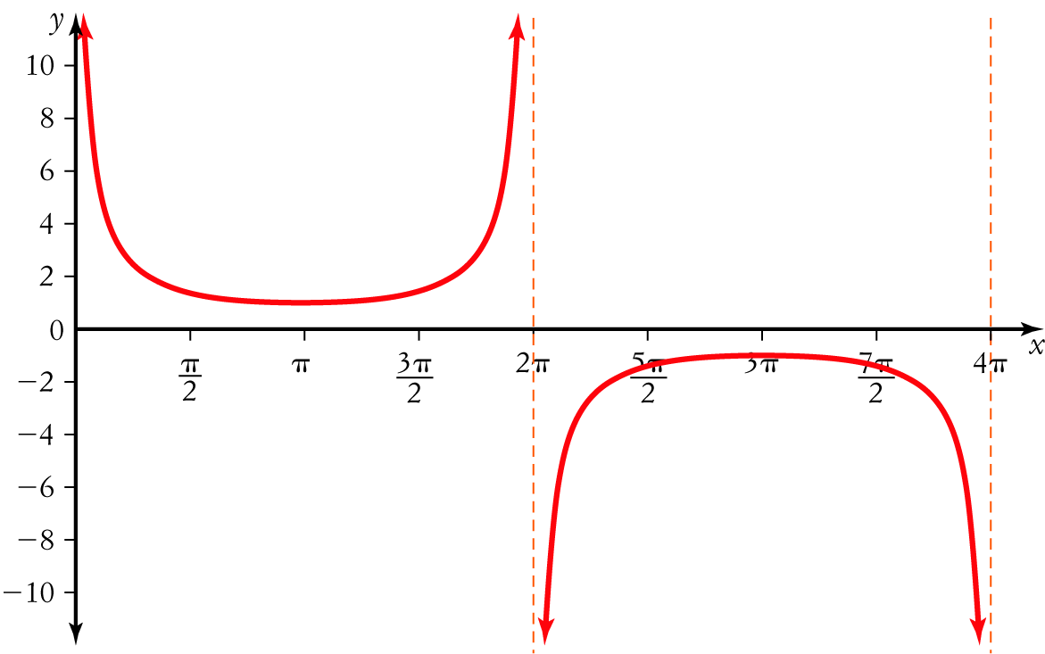

|  |  |
| --- | --- |
| A  y = 2 cosec (x)  B y = 2 sec (x − 1)  C y =  cosec (x) | D y =  sin (x)  E   y = cosec |

[1 mark]

6 The value of  is:

A  9 − 16i

B   25

C 5

D 9 + 16i

E −7

[1 mark]

7 The roots of x2 − 4x + 5 = 0 are:

A   x = 2 ± i

B (x − 2 − i)(x − 2 + i)

C  x = −2 ± i

D  x = −4 ± i

E  x = 4 ± i

[1 mark]

8 If  then the value of v2 is

A  2

B i

C 2i

D 4i

E   4

[1 mark]

9 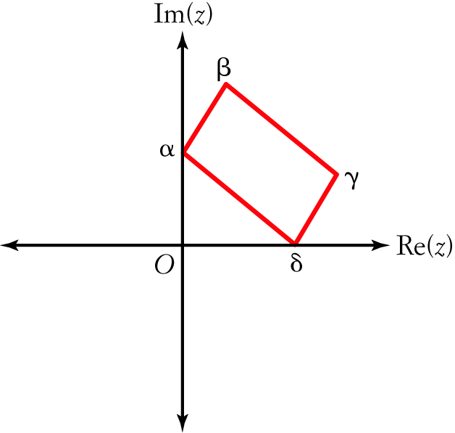

In the diagram, the complex numbers α, β, γ, δ form a parallelogram, such that α and δ lie on the axes. The point β is described by:

A   α + δ + γ

B  α + δ − γ

C α − δ − γ

D α − δ + γ

E −α − δ − γ

[1 mark]

Part B

9 short answer questions

35 marks

Show your working where appropriate.

10 Sketch the graph of y = −cosec (x) − 1 for 0 ≤ x ≤ 4π.

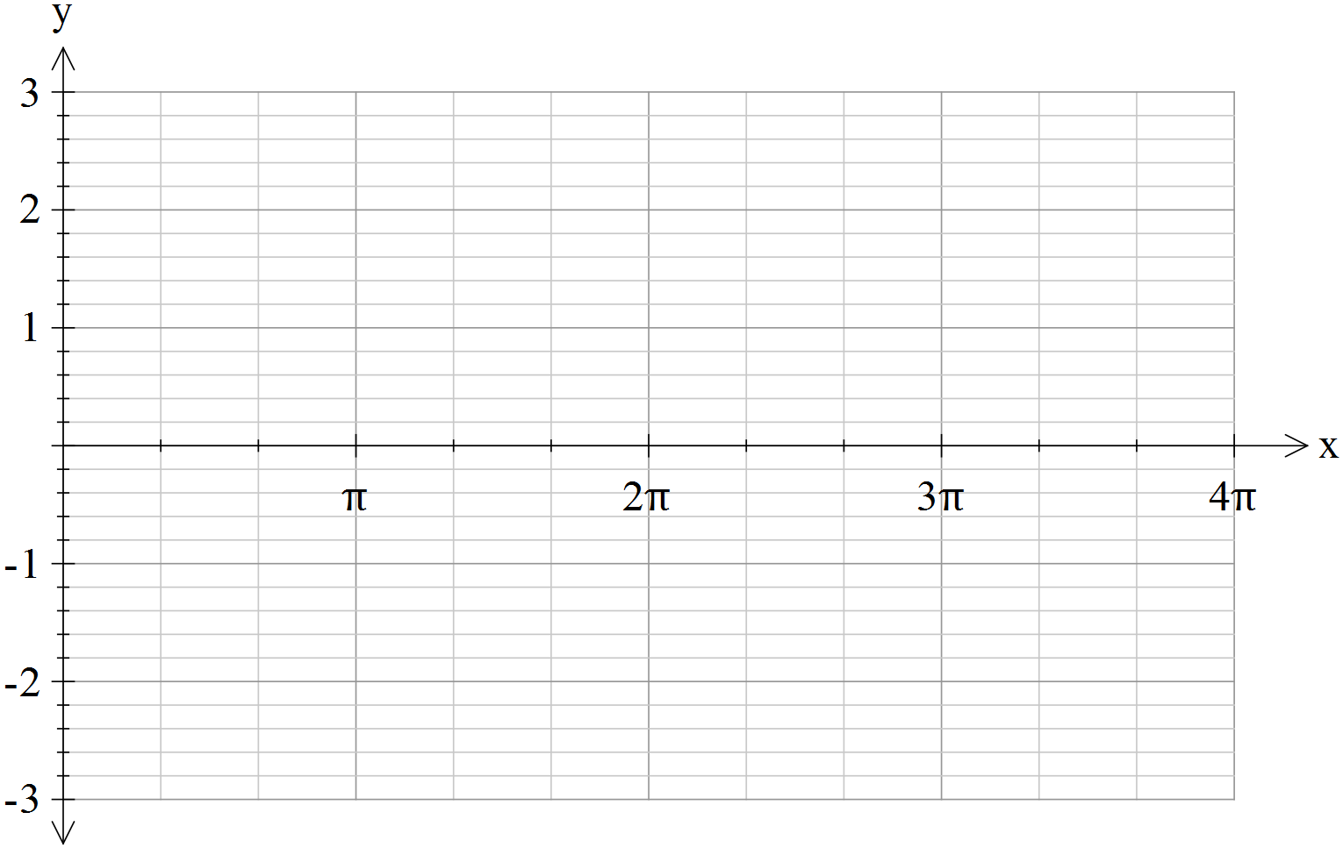

[4 marks]

Working and thinking space. Anything on this page below this line will not be marked.



11 Using the identity 1 + tan2 (θ) = sec2 (θ) evaluate  given that .

[ Your answer should be simplified to the form ]

[3 marks]

12 Using a suitable compound angle formula evaluate cos.

[4 marks]

13 Express sin sin  as a sum.

[3 marks]

14 a  Solve z2 + 3z + 3 = 0 over the complex plane.

b Sketch the solutions to z2 + 3z + 3 = 0 on an Argand diagram, labelling them z1 and z2.

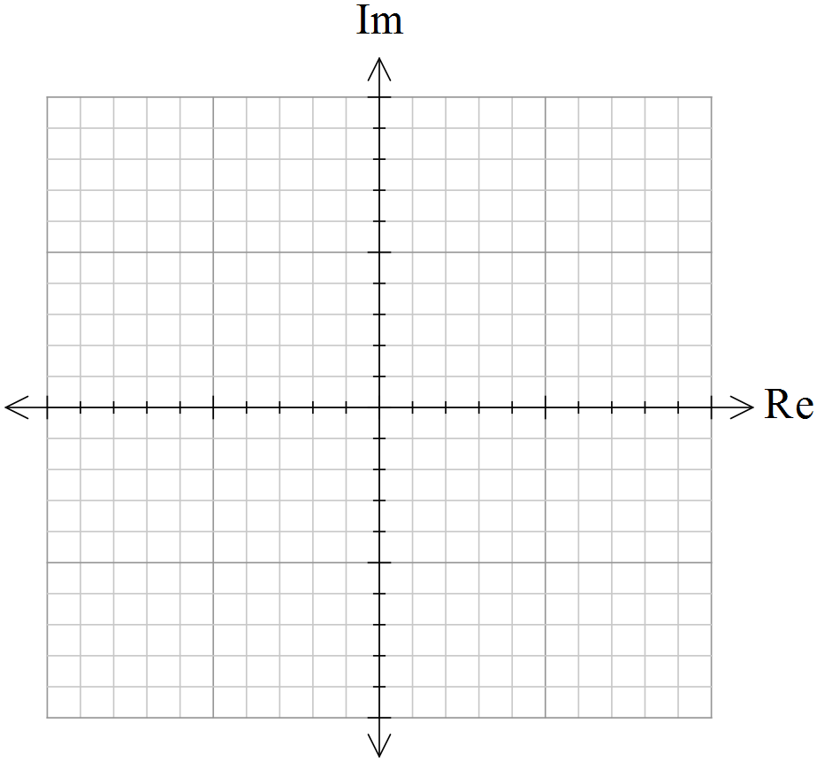

c  What geometric property do the complex roots of quadratic equations with real coefficients display?

[3,2,1 = 6 marks]

15 If (a + bi)2 = 5 + 12i, where a, b ∈ R. Find all possible values of a and b.

[5 marks]

16 If z = 6 + 8i find in simplest form:

a z−1

b 

c .

[6 marks]

17 If w = x + yi, where x, y ∈ R, show that:

a 

b 

[4 marks]

Part C

2 analysis questions

8 marks

Show your working where appropriate.

18 Rewrite the expression sin (2x) cosec (x) − sec (x) cos (2x) in terms of cos (x) only.

[3 marks]

19 Prove that cot2 (2θ) = .

[5 marks]